1. 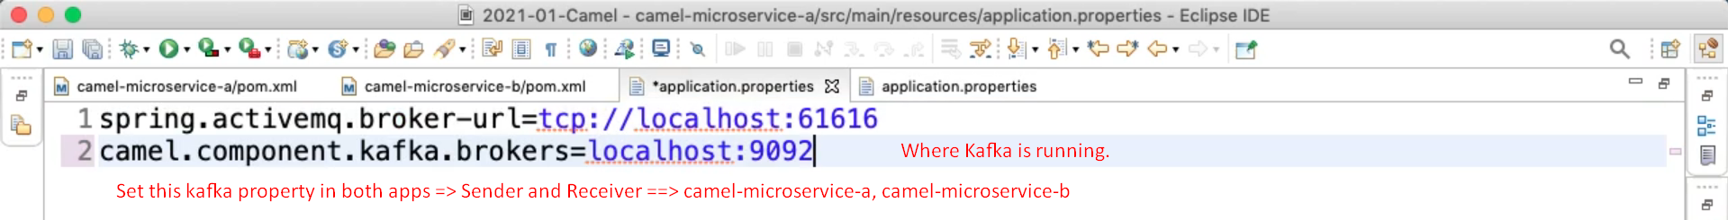
2. Graphical user interface, text, application, Word

   Description automatically generated
3. Let’s configure receiver router in camel-microservice-b  
   Graphical user interface, text, application, Word

   Description automatically generated
4. 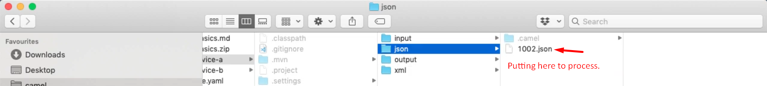
5. 